**Exercise**

**Managing Agile software delivery plans across teams**

**Exercise - Set up your environment**

* 4 minutes

In this section, you make sure that your Azure DevOps organization is set up to complete the rest of this module.

To meet these objectives, you:

* Set up an Azure DevOps project for this module.

**Get the Azure DevOps project**

Here you make sure that your Azure DevOps organization is set up to complete the rest of this module. You set it up by running a template that creates a project in Azure DevOps.

The modules in this learning path are part of a progression. You follow the Tailspin web team through their DevOps journey. For learning purposes, each module has an associated Azure DevOps project.

**Run the template**

Run a template that sets up your Azure DevOps organization.

Run the template

On the Azure DevOps Demo Generator site, follow these steps to run the template:

1. Select **Sign In** and accept the usage terms.
2. On the **Create New Project** page, select your Azure DevOps organization. Then enter a project name, such as *Space Game - web - Delivery plans*.

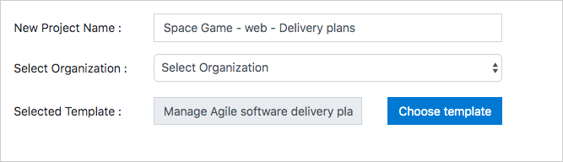

1. Select **Create Project**.

The template takes a few moments to run.

1. Select **Navigate to project** to go to your project in Azure DevOps.

**Important**

The **Clean up your Azure DevOps environment** page in this module contains important cleanup steps. Be sure to follow the cleanup steps even if you don't complete this module.

**Exercise - Plan a sprint using Delivery Plans**

* 10 minutes

Here you create a delivery plan and use it to plan a sprint in Azure DevOps.

The Tailspin team is eager to see how the Delivery Plans extension is going to work. They already have two teams with sprints set up in Azure DevOps, so now they can review and optimize the work schedules.

To do this, you:

* Install the Delivery Plans extension.
* Create a delivery plan.
* Add team sprints and milestones.
* Rearrange work items to fit the overall schedule.

**Install the Marketplace extension**

The Delivery Plans Marketplace extension provides the features needed to create and manage delivery plans. It integrates with Azure Boards to provide a seamless experience when planning work.

1. From a new browser tab, go to marketplace.visualstudio.com .
2. On the **Azure DevOps** tab, search for "Delivery Plans".
3. Select **Delivery Plans** from the results.

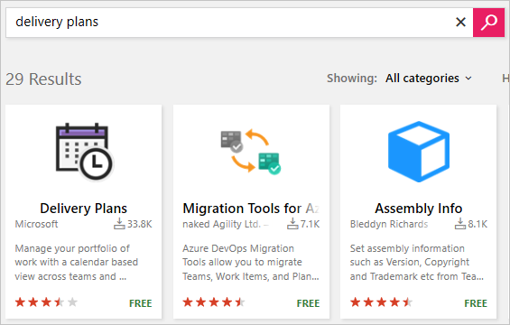

1. Select it and then **Get it Free**.
2. Select your Azure DevOps organization from the drop-down box.
3. Select **Install**.

**Create a delivery plan**

Delivery Plans adds a new **Plans** tab to Azure Boards. You can create as many delivery plans as you need to manage different aspects of your organization.

1. From Azure DevOps, navigate to your project.
2. Under **Boards**, select **Plans**.
3. Select **New plan**.
4. In the form, enter these fields:
   * **Name**: *Space Game Delivery Plan*
   * Select the **Backlog items** backlog for the **Space Game Web Team**
   * Add the **Space Game Engine Team's Backlog items** backlog using the **Add team** option
5. Select **Create**.

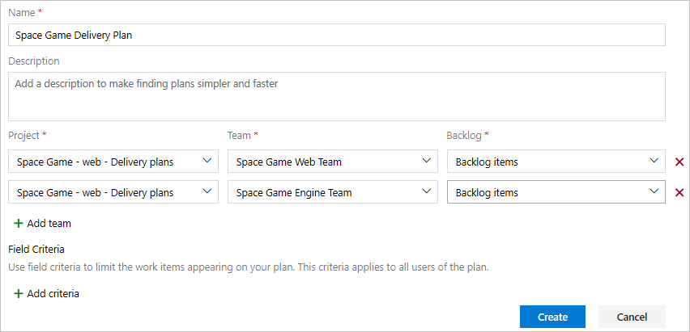

**Note**

The team project generated for this module uses the *Scrum* process and not the *Basic* process used in other modules in this learning path. While the Basic process uses *Issues*, the Scrum process uses *Backlog items*, which are functionally the same for the purposes of this module. You can use Delivery Plans with either process.

**Add schedule milestone markers**

Milestone markers can be added to the delivery plan as reference points. These help you plan work within the context of significant or external dates.

1. Select the **Configure plan settings** cog.

Configure plan settings

1. From the **Markers** tab, select **Add marker**.
2. In the form, enter these fields:
   * Select a date one week from now
   * **Label**: **Cliffchella**
   * **Color**: **Red**

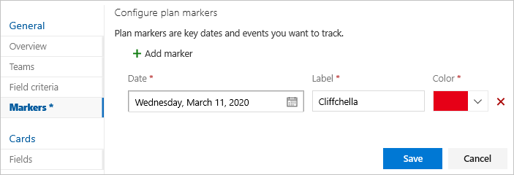

1. Repeat the process to add markers for:
   * **Beta**: five weeks from today (blue)
   * **Annual company party**: six weeks from today (green)
2. Select **Save**.
3. Select the blue marker at the top of the design plan. It will expand to show that it represents the beta milestone.

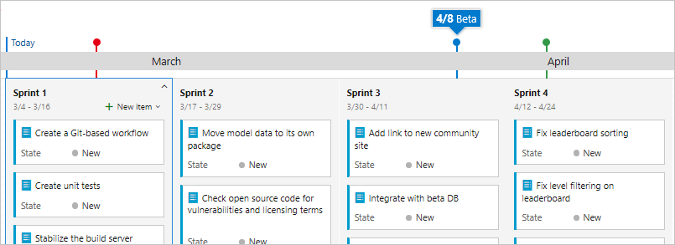

**Optimize the work schedule**

1. Notice that there is a work item for the Web team to **Integrate with beta DB** that is scheduled to be completed before the beta will be ready. This will be a problem because this work item is dependent on that beta.
2. Drag the integration work item from **Sprint 3** to **Sprint 4** to ensure that its dependency will be available.
3. This change opens a significant amount of bandwidth in **Sprint 3**. Since that time is now available for productive work, drag the two **Fix** work items from **Sprint 4** back into **Sprint 3**.

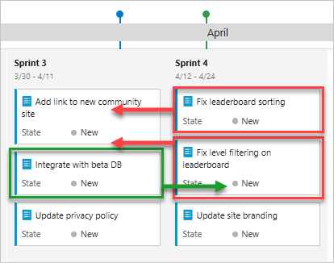

Your final sprint plan should look similar to this:

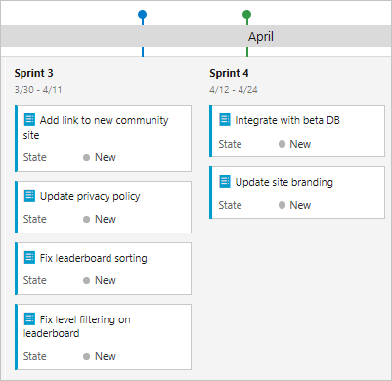

You've just completed some invaluable work that will impact the organization in a meaningful way. Management can feel confident that work will progress without foreseeable delays. And instead of waiting on dependencies to be delivered, teams will have always productive work to take on. Sure, things might change as circumstances develop, but at least now everyone knows where to go to stay up to date.

**Exercise - Clean up your environment**

* 3 minutes

You're done with the tasks for this module. Here you clean up your Azure DevOps environment.

**Optional - Delete your project**

This module provided a template that you ran to create a clean environment for the module.

Here you delete your Azure DevOps project, including what's in Azure Boards. In future modules, you can run another template that brings up a new project in a state where this module leaves off. Choose this option if you don't need your DevOps project for future reference.

To delete the project:

1. In Azure DevOps, go to your project. Earlier we recommended that you name this project **Space Game - web - Delivery plans**.
2. Select the gear icon next to the project name.

The icon might not appear until you move your mouse pointer over that area.

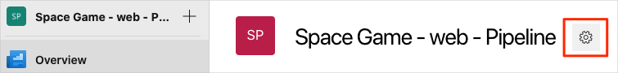

1. At the bottom of the **Project details** area, select **Delete**.

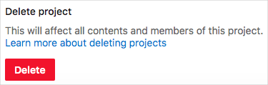

1. In the window that appears, enter the project name, and then select **Delete** again.

Your project is now deleted.